**Quiz 2**

**TOTAL POINTS 2**

Question 1

In the following confusion matrix for a credit card detection problem, what is the recall score for the machine learning model?

|  |  |  |
| --- | --- | --- |
| header | True Positive | True Negative |
| P​redicted Positive | 3​859 | 5​8 |
| P​redicted Negative | 9​2 | 2​8903 |

1 point

0.995

0.976

0.985

0.95

Recall score = TruePositives / (TruePositives + FalseNegatives)

3859 / (3859+92) = 0.976

Question 2

In general, for bias variance tradeoff, the total accuracy is equal to the sum of variance and the square of bias. In the following diagram, pick which line denotes the total accuracy, bias^2 and variance?

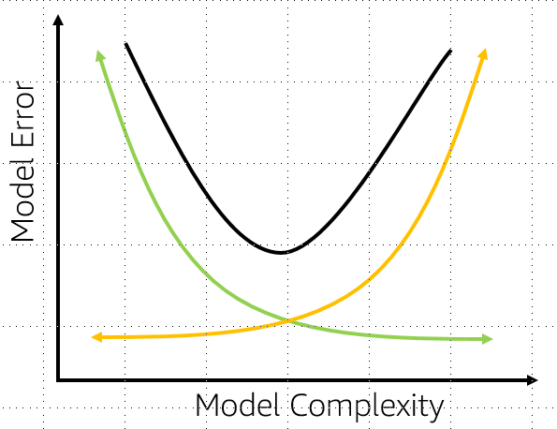

1 point

Green line: Bias^2, Orange line: Variance and black line: total error

Green line: Variance, Orange line: Bias^2 and black line: Variance

Green line: Bias^2, Orange line: total error and black line: Variance

Green line: total error, Orange line: Variance and black line: Bias^2